External DSL

📌 Definition:
# Source: AI Source: Provided by: [Data Path: Persons Table -> ID Column: 1, Name_En Column: Motasem Essam] -> From: [Chatgpt (GPT‑5 Mini)] on [12/9/2025]
An External DSL is a standalone language with its own syntax and rules, designed for a specific domain or purpose.

🧠 Simple idea:
# Source: AI Source: Provided by: [Data Path: Persons Table -> ID Column: 1, Name_En Column: Motasem Essam] -> From: [Chatgpt (GPT‑5 Mini)] on [12/9/2025]
External DSL = A completely separate language for one specific job

🔍 Key characteristics:
# Source: AI Source: Provided by: [Data Path: Persons Table -> ID Column: 1, Name_En Column: Motasem Essam] -> From: [Chatgpt (GPT‑5 Mini)] on [12/9/2025]
- ✅ Has its own syntax (not tied to another language)
- ✅ Designed specifically for a particular domain
- ✅ More expressive and powerful within that domain
- ❌ Requires its own parser/interpreter/compiler

🧩 Examples:

🗄️ SQL (Query Language)
# Source: AI Source: Provided by: [Data Path: Persons Table -> ID Column: 1, Name_En Column: Motasem Essam] -> From: [Chatgpt (GPT‑5 Mini)] on [12/9/2025]
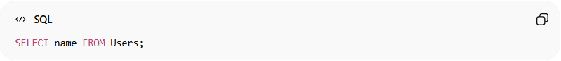
SELECT name FROM Users;

🏷️ HTML (Markup Language)
# Source: AI Source: Provided by: [Data Path: Persons Table -> ID Column: 1, Name_En Column: Motasem Essam] -> From: [Chatgpt (GPT‑5 Mini)] on [12/9/2025]
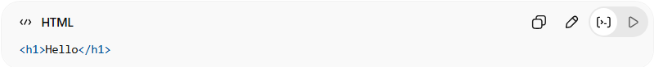
<h1>Hello</h1>

🎨 CSS (Style Sheet Language)
# Source: AI Source: Provided by: [Data Path: Persons Table -> ID Column: 1, Name_En Column: Motasem Essam] -> From: [Chatgpt (GPT‑5 Mini)] on [12/9/2025]
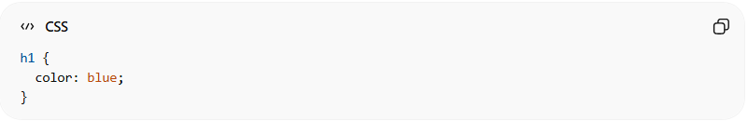
h1 {
color: blue;
}

⚙️ How it works:
# Source: AI Source: Provided by: [Data Path: Persons Table -> ID Column: 1, Name_En Column: Motasem Essam] -> From: [Chatgpt (GPT‑5 Mini)] on [12/9/2025]
- You write code in the DSL
- A specific engine/tool interprets or processes it
- It performs a domain-specific task (query, structure, styling)

🆚 External vs Internal DSL
# Source: AI Source: Provided by: [Data Path: Persons Table -> ID Column: 1, Name_En Column: Motasem Essam] -> From: [Chatgpt (GPT‑5 Mini)] on [12/9/2025]
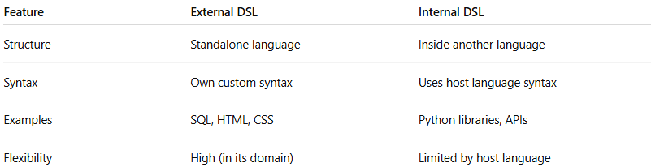
Feature | External DSL | Internal DSL
Structure | Standalone language | Inside another language
Syntax | Own custom syntax | Uses host language syntax
Examples | SQL, HTML, CSS | Python libraries, APIs
Flexibility | High (in its domain) | Limited by host language

🎯 Summary:
# Source: AI Source: Provided by: [Data Path: Persons Table -> ID Column: 1, Name_En Column: Motasem Essam] -> From: [Chatgpt (GPT‑5 Mini)] on [12/9/2025]
External DSLs are independent languages built specifically for one domain, with their own syntax and tools.

🧩 Quick connection:
# Source: AI Source: Provided by: [Data Path: Persons Table -> ID Column: 1, Name_En Column: Motasem Essam] -> From: [Chatgpt (GPT‑5 Mini)] on [12/9/2025]
- Internal DSL → inside Python/Java
- External DSL → standalone like SQL, HTML, CSS

